Observers: A. Moors Survey Results: 1 male STOC heard
Mountain Range: Pinaleño
Quad map name(s): Webb Peak, AZ General habitat: mixed conifer
Visit#: DS1
Sunrise or Sunset Time: 0518
Times For: | Start (24-hr) | End (24-hr) | Total  (~ ¼ hour)
Hike-in: | 0428 | 0440 | 0.25
Survey: | 0440 | 0610 | 1.5
Hike-out: | 0610 | 0640 | 0.5
Weather: | Survey
Weather: | Start | End
Wind (range mph): | 0-10 | 0-10
Clouds (%): | 0 | 0
Precip: | 0 | 0
Temp (F): | 50 | 54

Mexican Spotted Owl Locations are reported in table below
 |  |  | Response |  | NAD83
SPP | Sex | Age | Type | Time | UTM-E | UTM-N
STOC | M | U | A | 0448 | 601508 | 3617640
Use the following codes:
SPP = STOC for Mex Spotted Owl
Sex: F = female, M = male, U = unknown
Age: A = adult, S = subadult, Y = branched
young; H = hatchling or nestling
Response Type: V = seen, A = heard,
N = none, NEST = Nest found,
D = dead owl found
Time = 24 hr time of response

Mousing Used? N Number Used:

I = Ignores;
 | Fates of Mice Initially Taken By The
Mouse # | Male | Female | Unknown
1:
2:
3:
4:
5:
6:
C = cached;
F = given to female out of nest;
M = given to male;
Y = given to young;
N = taken to nest or to female in a nest;
A = eaten by individual that took the mouse;
L = left with mouse and fate unknown;
G = mouse got away;
H = held for 1 hour.

Nest located? N Evidence used: Day roost located? N

Other raptors seen or heard during survey: heard Peregrine falcon wailing but not sure where, sounded uphill

Comments:

Originally planned to survey Ash Creek this morning, but drove over there and it was howling wind >20 mph (0415 hrs), so I changed plans and went to Webb Peak since it’s more sheltered from wind. Started Webb Peak hike in from trail in soldier creek campground at 0428. Headed down trail and then got off trail toward where I heard male last night. Paused at 601248, 3617641 (PT1 on map) and hooted a couple times. Got male response far below me at 0448 hours. Bearing = 90 degrees. I headed down toward him. I stopped near where Tony got male roosted last year, but I think the male I heard this morning is much farther downslope. I hooted several times and played slur call on phone. No reply. I am at 601319, 3617655 from 0500 to 0515 (PT2 on map). Does not look very safe to get farther down from where I am, so decided I would search around here. Spent some time recording notes at 601277, 3617615. Not great STOC habitat around here. There are large fir but seems fairly open and has several pockets of young aspen (assume from past fires burning here). Lots of dead and down logs and branches make the hiking challenging. Hillside looks dug up from coatis or bear. Heard Peregrine falcon wailing briefly, but unsure of it’s location. It sounded uphill….perhaps it’s the one I have heard on the Goudy side before. 0545 hrs, hiked around looking for more sign uphill and found 2 splats of whitewash in two locations higher up toward trail. Whitewash at 601191, 3617551 at 0605 hrs. And more near main trail at 601162, 3617531 at 0611 hrs. Looks like fairly fresh STOC whitewash.
Back at jeep at 0640. Visited camp hosts briefly.

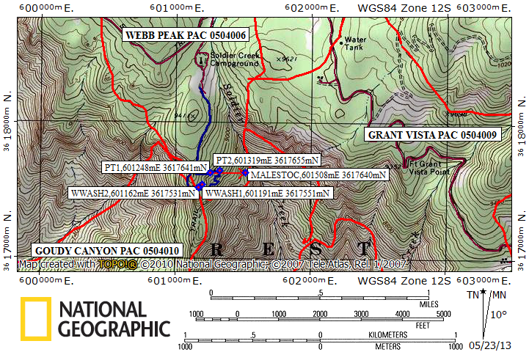
Red lines = PAC boundaries, Blue line = path walked

